|  |  |
| --- | --- |
|  | **2025 All Stars - Team Parent Checklist** |

Congratulations on your upcoming All Stars Season, one of the best Little League experiences you and your player will participate in! Team Parents play a critical role in ensuring things go smoothly and everyone has fun. Please use this checklist as a guide to prepare for the weeks ahead.

|  |
| --- |
| **Player Packet Forms** |

Players are eligible to play with that league only if they reside, or the physical location of the school where they attend classes is, within the boundaries provided to, and approved by, Little League International. To confirm eligibility, several documents are required. The league will send an email to selected players parents to let them know about the following documents that are needed. Team Parents will collect and compile the following documents and provide to our Player Agent. The documents outlined below are compiled into “Player Packets” in an official “team binder”. If documents are not provided by the deadline established, players become ineligible.

1. [Tournament Player Verification Form](https://www.millcreeklittleleague.com/Portals/52001/docs/2024/Tournament%20verification%20form.pdf)
   * Must be 2025 form
   * Previous years' forms can be used if there has been no change to residence or school
2. Player’s Original Birth Certificate
   * Provide a hard copy original and one copy of the player’s original birth certificate
   * If a player has an approved Tournament Player Verification Form from a previous year AND their address used for verification has not changed you do not need to provide the original birth certificate. If anything has changed you must have the original birth certificate.
   * These are returned to parents after our District One representative reviews the team binder. If returned, please keep a copy in the binder.
3. School Enrollment Verification ***or*** Proof of Residency
   * As outlined in [Residency & School Attendance Eligibility Checklist](https://www.littleleague.org/downloads/residency-checklist/), ***choose one option***:
     1. School Enrollment Verification
        + This is the easiest option; and we suggest you use this verification method.
        + Complete the [School Enrollment Verification](https://www.millcreeklittleleague.com/Portals/52001/docs/2024/School%20Enrollment%20Form.pdf) and have it signed by the school’s School Administrator, Principal, or Vice Principal.
        + If the player participated in All Stars last year, and the player hasn’t changed schools, you can use the previous year’s form.

**OR**

* + 1. Proof of Residency
       - The family must provide **one piece of documentation from each of the three groups.** The dates on the documentation must be 2/1/2024-2/1/2025 anything dated prior to or after those dates will not be accepted.
         * Group #1: driver’s license, school records, vehicle records, employment records or insurance documents
         * Group #2: welfare/childcare records, federal records, state records, local records, support payment records, homeowner or tenant or military records
         * Group #3: voter’s registration, utility bills, financial records, medical records or internet, cable, or satellite records

1. [Model Release Form (photo release)](https://www.millcreeklittleleague.com/Portals/52001/docs/2024/Form%20Release%20and%20Waiver.pdf)
   * This is a photo release form - must be a 2025 form
2. [Medical Release Form](https://www.millcreeklittleleague.com/Portals/52001/docs/2024/Medical%20Release%20Form.pdf)
   * Must be a 2025 form - can be the same one used in a current year inter-league tournament.
   * Place this form backwards at the back of the packet so it is visible.

|  |
| --- |
| **Manager / Coach Packets** |

All teams can have 3 coaches (1 Manager and 2 assistant coaches). All managers/coaches must provide the following 4 certificates for each All Stars season. If you submitted for the regular season, please just re-submit:

1. [Concussion Training Certificate](https://www.train.org/cdctrain/course/1089818/details)
   * Required every 3 years
   * Certificate must have completion date 2023 or later
   * Log-in to your account to get certificate
2. [Sudden Cardiac Arrest Training Certificate](https://nfhslearn.com/courses/sudden-cardiac-arrest)
   * Required every 3 years
   * Certificate must have completion date 2023 or later
   * Log-in to your account to get certificate
3. [Abuse Awareness for Adults Certificate](https://www.littleleague.org/university/articles/abuse-awareness-training-course/)
   * Must be completed annually (done in 2025)
   * Log-in to your account to get certificate
4. [Diamond Leaders Training Certificate](https://www.littleleague.org/diamondleader/)
   * Only required once – can have any date on certificate
   * Log-in to your account to get certificate

|  |
| --- |
| **Team Binder** |

Team binders must contain the following documents. Team Parents only need to collect and provide #1 - #3:

1. Player Packet / Forms (listed on page 1)
2. Manager Packet / Forms (listed on page 2)
3. Team Contact Information Sheet (page 4)
   * Needs to contain the names, emails, and phone numbers for the team’s manager, up to 2 coaches and two team volunteers (people willing to keep score & pitch counts).
   * Provide two copies - one to turn in at binder checks and one to keep in the team binder.
   * Team Parents provide this document.
4. Team Affidavit
   * The Player Agent will provide this document, which is available in the Little League Data Center.
5. League Map
   * This is a map that plots all players places of residency or school.
   * The Player Agent will provide this document, which is available in the Little League Data Center.
6. Tournament Charter Proof
   * The Player Agent will provide this document, which is available in the Little League Data Center.
7. League Proof of Insurance
   * The Player Agent will provide this document, which is available in the Little League Data Center.
8. [Little League Baseball Bat Rules](https://dt5602vnjxv0c.cloudfront.net/portals/11519/docs/rules/little%20league%20bat%20rules.pdf)
   * The Player Agent will provide this document.

|  |
| --- |
| **Helpful Information** |

**Uniforms & Little League Patches**

* Jerseys and hats will be provided before tournaments begin.
* All Stars uniforms must have official [Little League International patches](https://www.littleleague.org/playing-rules/patch-requirements/) attached to jerseys.
  + The league will provide patches to Team Parents.
* Parents must attach patches to their player’s uniform:
  + 3” below left shoulder seam on raglan sleeve
  + 1” below left shoulder seam on set-in sleeve
  + If sleeveless, the patch should be placed over the left breast

**Player Pennants**

* The league provides custom pennants that are hung on the backstop at games.

**All Stars Celebration**

* The league hosts All Star Celebrations to kick off the All Stars season.
* Parents from the teams are asked to help.

**Snack Wagon / Nut Hut**

* Team Parents should organize a portable snack option (i.e., wagon of healthy snacks/drinks).
* Teams meet before games to get energized.
* The cost should be split between parents.

**Fun Stuff**

* Chalk Car Windows -Teams like to get together and decorate car windows with chalk markers.
* Teams typically get together and have a BBQs/party before games start and throughout the tournaments.

**District One Tournaments**

* Mill Creek Little League participates in the Washington [District One Tournaments](https://www.littleleaguewad1.org/Default.aspx?tabid=1068123) (click for times/brackets).

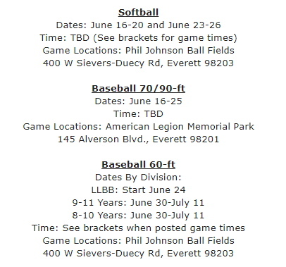

**State Tournaments**

* Teams that win District Tournaments, advance to play in the [Washington State Little League Tournament](https://www.littleleaguewa.org/2025-state-tournament-dates-locations/).
* If teams have a good chance of winning at Districts, and travel would be required to participate on the State tournaments, we recommend that the team makes hotel reservations asap. Teams coordinate and pay for their own accommodations.
* 11U play ends at the State level (they don’t participate in regional tournaments or the LL World Series).

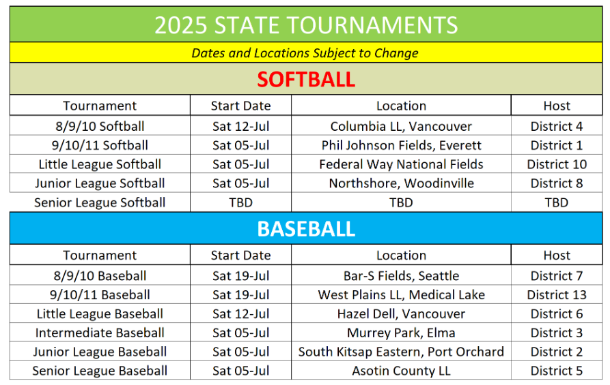

**Regional Tournament**Teams (12U and up) that win the State Tournament, advance to play in the [West Regional Tournament](https://www.littleleague.org/region/west-region/) in San Bernardino, CA.

**Little League World Series**Teams that win Regionals, advance to play in the [Little League World Series](https://www.littleleague.org/world-series/) in Williamsport, PA (baseball) or Greenville, NC (softball).

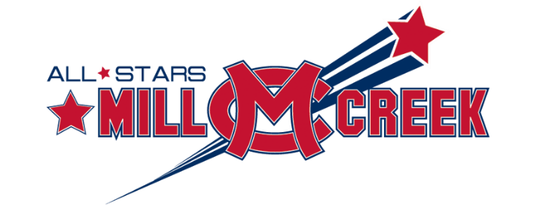

**Mill Creek Little League**

**All Stars Team Contact Information Sheet**

Please provide the names, emails, and phone numbers for the team’s manager, up to 2 coaches and two team volunteers (people willing to keep score & pitch counts). Provide two copies - one to turn in at binder checks and one to keep in the team binder.

|  |  |  |
| --- | --- | --- |
| **Manager Name** | **Email** | **Phone Number** |
|  |  |  |
| **Coach Name** | **Email** | **Phone Number** |
|  |  |  |
| **Coach Name** | **Email** | **Phone Number** |
|  |  |  |
| **Scorekeeper / Pitch Counter** | **Email** | **Phone Number** |
|  |  |  |
| **Scorekeeper / Pitch Counter** | **Email** | **Phone Number** |
|  |  |  |